Exams on the exam.net platform

Instructions for students

May 12th 2020 release
Before the exam
1. After registering to the exam through UNIMIA, wait for the email confirmation specifying:
- the exam date and time (they may be different from those provided at the time of registration, depending on the number of participants);
- the web conference system, with instructions for connecting through your smartphone;
- the type of exam: computer-based written exam, written exam partially or totally on paper;
- a reminder to read carefully and follow the instructions provided in this document ("Exams on the exam.net platform - Instructions for students").
2. The exam.net platform requires a specific browser, called SEB (Safe Exam Browser) which prevents the candidate from performing any operation on his computer other than the exam. If you have never taken an exam on this platform, access this link well in advance: https://support.exam.net/#/seb, select the installation file suitable for your operating system (Windows or macOS) and follow the installation instructions.
Please note: As with any other software, to install SEB on your computer, you must have administrator rights, or the administrator password.
Please also note: do not run SEB as a stand alone program, since it requires a configuration file which is passed from the exam.net platform.
3. Download well in advance the App of the web conference system required by the teacher, as notified to your smartphone, and make sure that your smartphone is able to scan a QR code (or download the App to do so).
4. Set up the workstation to be used during the exam, bearing in mind that you will have to:
    - connect with your smartphone to the web conference, at the request of the teacher provide a view of the room where you will sit for the exam, show your identity document via your smartphone;
    - then position your smartphone so that it frames you and your workstation from behind, as shown in Figure 1, for example by placing it on a library shelf or on the shelf of a fairly high piece of furniture, and make sure that it holds still;
    - connect your smartphone to the power supply to prevent the battery from running low during the exam;
    - make sure your computer is connected to the power supply for the duration of the exam.
— Figure 1 —

During the exam
1. Keep an identification document handy (preferably a student badge, or an identity document).
2. Using your smartphone, run the web conference App at the specified time with the credentials emailed by the teacher, and wait for your turn.
3. At the request of the teacher, provide a view of the room using your smartphone, show your identification document (show only the portion of your identity document containing your picture, name and surname), then position your smartphone so as to obtain a frame similar to that shown in Figure 1, keeping the microphone on and avoiding any noise for the duration of the exam;
4. Sit at your workstation, close all applications running on your computer, connect to the website https://exam.net/ using any browser (Figure 2), and wait for the exam to start. Select the language by clicking on Exam.net at the top left of the screen.
5. Enter the exam key read out by the teacher, enable Open Safe Exam Browser (as shown in Figure 3) and wait for the SEB to set up the computer in Safe Exam mode. You will be required to enter the exam key again.
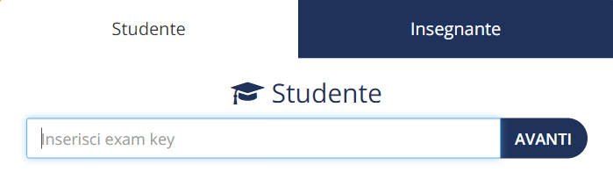
— Figure 2 (computer) —

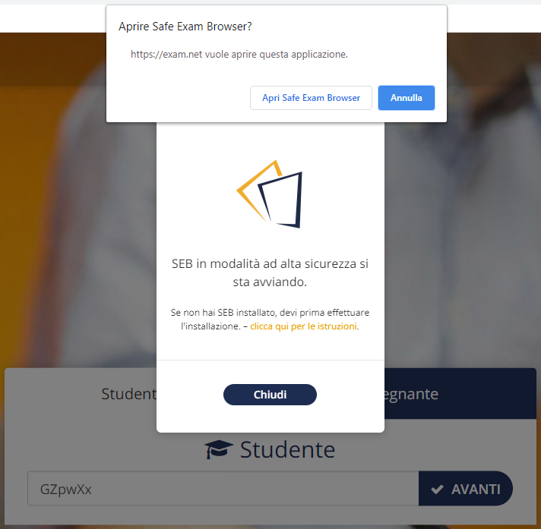
— Figure 3 (computer) —
6. Enter the required data (namely your student ID number) and confirm by clicking on RETRIEVE EXAM. You will see a screen similar to the one shown in Figure 4, depending on the type of exam prepared by the teacher, where:
- the orange-background icons allow you to change the display mode and to copy and paste;
- the upper part of the screen displays the exam questions (if the teacher used a pdf file, the zoom in and out controls will appear among the orange-background icons);
- the lower part of the screen is for typing in your answers;
- the controls at the top left allow you to:
  - run a private chat with the teacher (Teacher chat);
  - scan exam materials written on paper (if any). (Scan solution). You may scan just before submission, with the express verbal authorization of the teacher, as indicated below;
  - go back to the original view (View exam);
  - deliver your work (Submit exam).
7. Taking your exam. For the duration of the exam:
- make sure no one enters the room;
- do not make noises, as the exam takes place with microphones on;
- do not ask any questions to the teacher, for the same reason; if necessary, use the private chat (Teacher chat);
- in case of lost connection, reconnect immediately to the web conference; if this is impossible, report it via the chat and agree on another date with the teacher;
- wait until the time expires without leaving your desk.

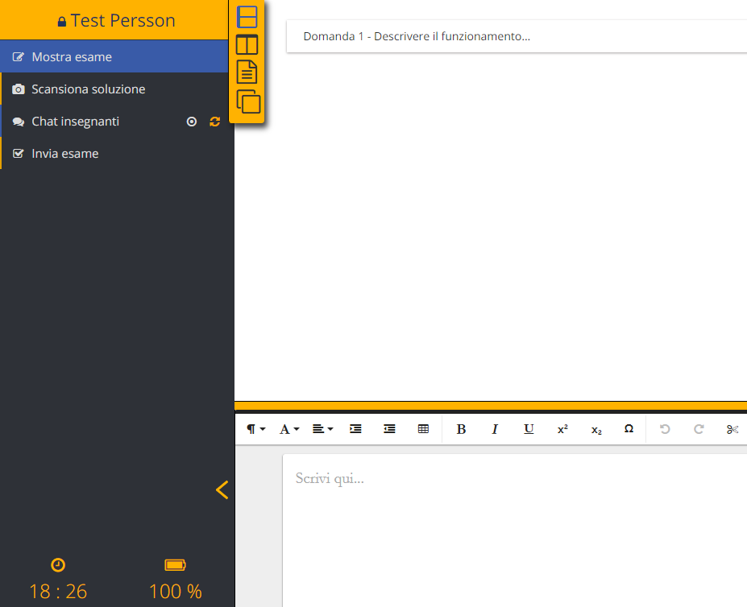
— Figure 4 (computer) —

Once you have completed your exam
1. If you do NOT have to submit any materials written on paper, click on Submit exam (last control among those shown at the top left in Figure 4) to deliver your work.
2. If part or all of the materials to be submitted are written on paper:
- run the scan function on the computer using the control Scan solution: the QR code will appear as shown in Figure 5;
- frame the QR code with your smartphone: the link to be followed will appear (Figure 6a) or you will be directed to the page scanning procedure (Figure 6b);
- for each sheet of paper to be scanned, repeat the following steps:
  - by clicking on your smartphone on Scan solution, you can run the camera and take a picture of the written sheet; after confirming that the picture is legible, you will be able to rotate the image (Figure 6c), if necessary, and upload it to the exam.net platform (Upload);
  - once the image has been uploaded, the message shown in Figure 7 will appear on your computer screen, asking you to enter the code shown on your smartphone (Figure 6d: 831 in the example);
  - after entering and confirming the code on your computer, you can click again on Scan solution on your smartphone, and scan the next page;
- at the end of the scanning activity, the scanned pages will appear in the area intended for typing answers, to which you can return using the control View exam (Figure 4);
- after checking the correct arrangement of the scanned pages, end the exam by clicking on Submit exam (last control among those shown at the top left in Figure 4) to deliver your work.

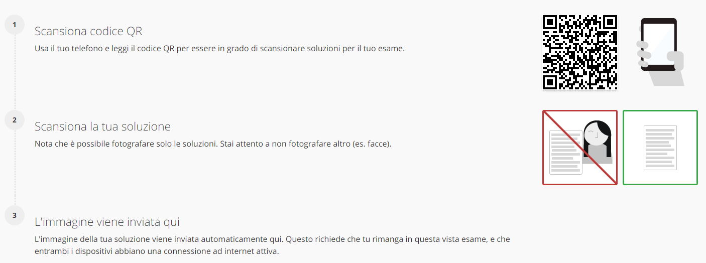
— Figure 5 (computer) —
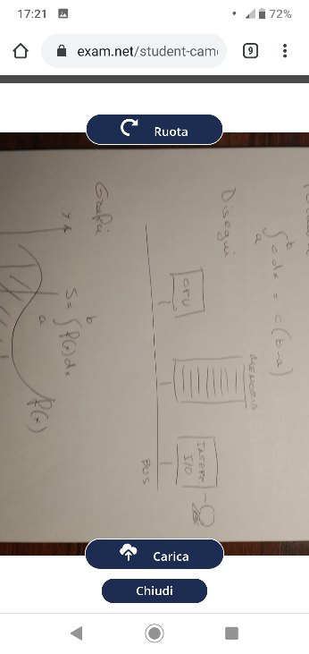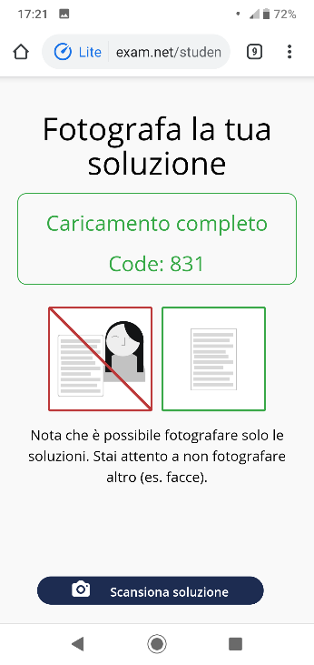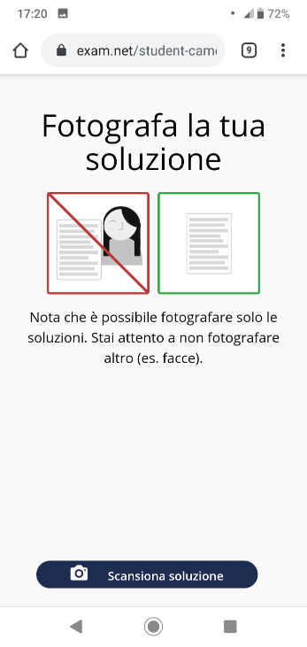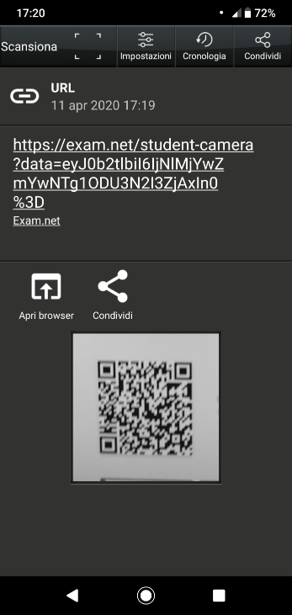 a b c d
— Figure 6 (smartphone)—

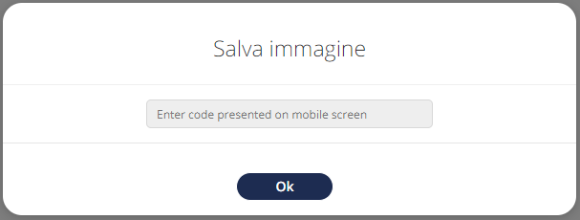
— Figure 7 (computer) —

